Drug Addiction

Specification document

Name: Michael Harrington
ID: C00296932
Supervisor: CM

Table Of Contents

Date: 22/1/2026 2
Use case diagram: (Functional Requirements) 2
Use Cases: 3
GUI Mock-Ups: 6
Testable Non-Functional Requirements: 9

Date: 22/1/2026

Use case diagram: (Functional Requirements)

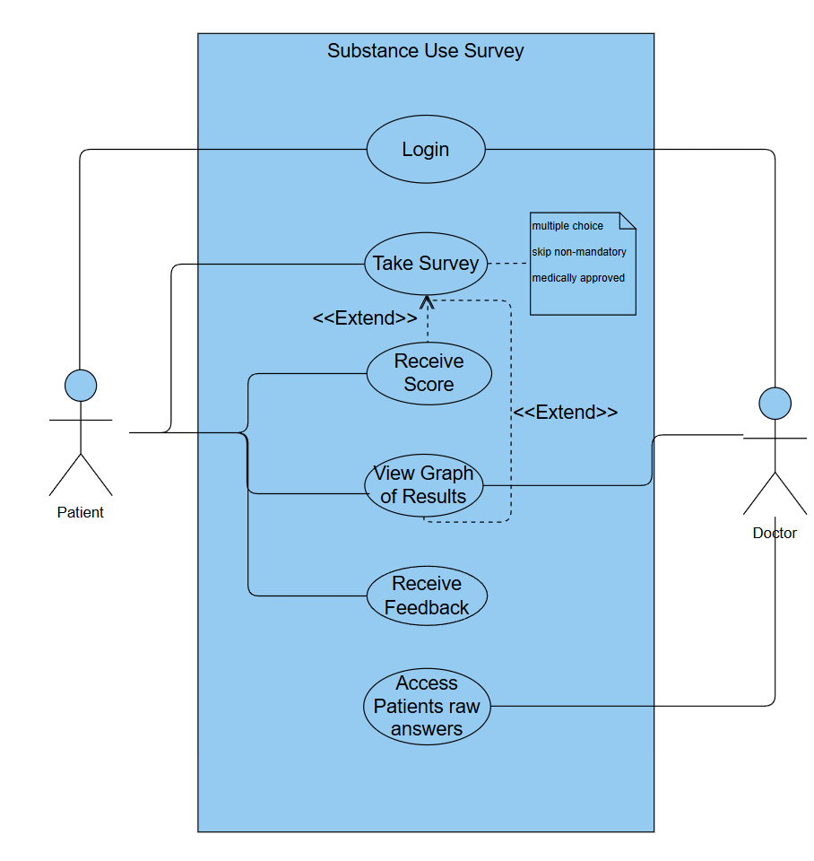

Use Cases:

Name | Take Survey
Description | The user will be able to take a survey for a specific drug addiction and answer a set of questions that follow GDPR.
Actors | Patient
Frequency of Use | Survey can be taken whenever to monitor your levels of addiction
Triggers | The use case can be triggered after the Patient has logged in and clicks the “take survey” button.
pre-conditions | Patient must be logged in.
Main Course | - Patient first creates an account on the website  - Patient then logs in with their details  - Finally the patient clicks the take survey button.

Name | Login
Description | The User will be able to login to take the survey as well as the doctor to view the raw answers from the patients.
Actors | Patient, Doctor
Frequency of Use | The Login is required every time the patient or doctor wants to use the service.
Triggers | After entering the website the Patient is prompted to login.
pre-conditions | The patient or doctor must have previously created an account.
Main Course | 1.Patient or doctor first creates an account  2.Patient or doctor are then prompted to login using the details they entered for the sign-up.

Name | Receive Score
Description | The user will be able to take a survey for a specific drug addiction and answer a set of questions that follow GDPR.
Actors | Patient
Frequency of Use | Patients can receive the score of their test following each completion.
Triggers | The score is Received after the patient completes the survey
pre-conditions | Paint must be logged in and have completed the survey
Main Course | - Patient must first be logged in  - Patient takes the survey and completes all required questions  - Patients can then view the score of their completed survey.

Name | View Graph of Results
Description | The patient or doctor is able to view a graph based on the results of the patient's surveys.
Actors | Patient, Doctor
Frequency of Use | For the patient, the graph can be viewed when they complete the survey or if they view past results on their profile.  For the Doctor, they can view the graph of any patient that has taken the survey
Triggers | This use case can be triggered by entering the Patients profile and viewing past survey results or after completing a survey.
pre-conditions | Patient or doctor must be logged in and patient must have previously completed a survey
Main Course | - Patient or doctor must be logged in  - Patient must access their profile storing the information of past survey results  - Doctors must view the database of all patients and choose one to view a survey of.

Name | Access patients raw answers
Description | The Doctor can access the Raw answers from the patients that took the survey
Actors | Doctor
Frequency of Use | Used every time the doctor wants to view the raw data the patients gave.
Triggers | This use case can be triggered when the doctor wishes to view information of the patients that took the survey
pre-conditions | The doctor must be logged in.
Main Course | - Doctor must first be logged in  - The doctor then must access the database off all patients that have taken the survey  - Finally the doctor chooses a patient to view the raw results of.

GUI Mock-Ups:

Main menu:
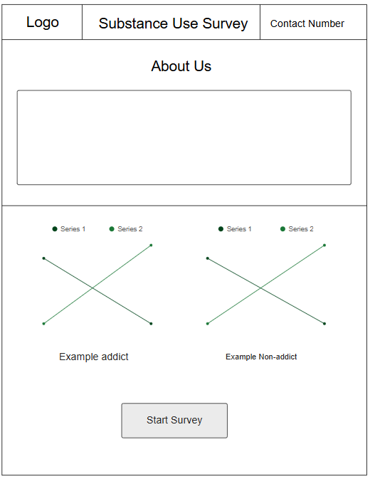

Login/Sign up:

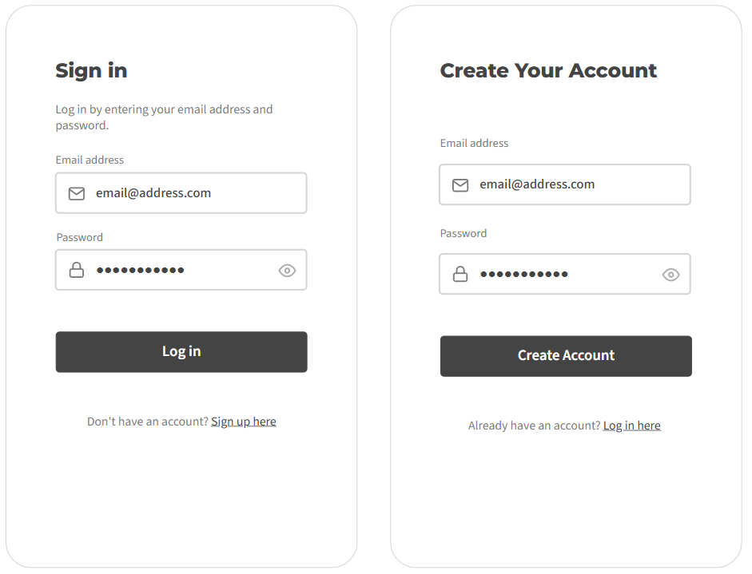

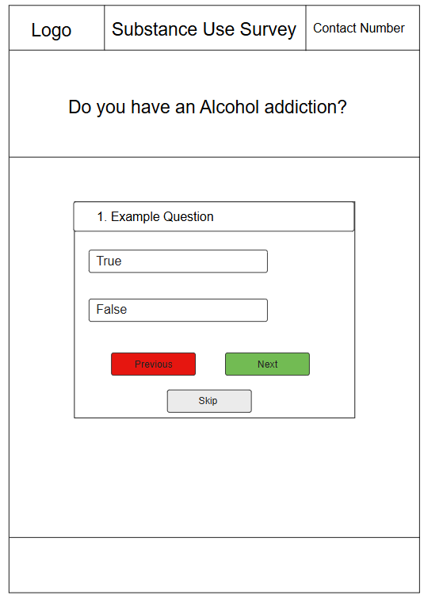
Survey Screen:

Testable Non-Functional Requirements:

A Clear Privacy Policy:
The website will display a privacy policy page that explains what data is collected.
Verification: Manual Inspection

GDPR (Non-Hackable):
Website will comply with GDPR requirements

Verification: Legal compliance audit

Desktop, mobile and tablet friendly:
The website will be fully usable on all three devices

Verification: Cross-device testing

Results are not a diagnosis:
Big disclaimer stating that survey results are not a medical diagnosis on the main and survey pages

Verification: UI inspection

No tracking data without consent:
The website will not store any tracking cookies until the user has provided consent

Verification: Cookie audit

